- What are the major differences between the same devices from different brands?
The major differences typically lie in performance, features, software, scalability, and cost. For example:

  - Routers: Cisco ISR 4321 provides strong enterprise-grade security and stable throughput, Juniper SRX345 offers higher scalability and redundancy, and TP-Link TL-ER7206 is more cost-effective but limited in features.
  - Switches: Cisco Catalyst 9300 and 9500 series differ in throughput, Layer 3 capabilities, and port configurations. Higher-end switches offer greater reliability, advanced features, and faster uplinks, while lower-end or competitor models may be sufficient for smaller deployments but lack advanced routing options.
  - Wireless Access Points: Cisco 1850/9115AX supports WiFi 6 and higher user capacity, Ubiquiti UAP-AC-Pro offers moderate speed and coverage, while TP-Link EAP245 is cheaper but supports fewer concurrent users.
  - Servers: Dell PowerEdge R550 provides high RAM capacity, dual CPU support, and virtualization readiness; HPE ProLiant and Lenovo ThinkSystem offer lower-cost options with limited expansion.
  - Printers: HP, Canon, and Brother devices differ in speed, energy efficiency, and reliability, affecting suitability for high-usage environments like student lounges.

Overall, the differences reflect trade-offs between cost, performance, scalability, and advanced features, making brand and model selection crucial depending on the lab or network requirements.

Reflection Task 3

By comparing networking devices from different brands, we learned that price differences usually reflect performance, reliability, security features, and scalability. Enterprise-level networking devices are more expensive, but they provide better stability and long-term support, which are important for a faculty network. However, we also realised that the most expensive option is not always the best choice for an educational environment.Through this task, we learned to consider cost-effectiveness when selecting devices. With a limited budget, it is necessary to balance performance, reliability, and price to meet actual requirements. This process helped us better understand how device selection affects the overall network design and budget planning.

TASK 4

Identify the Work Area on the Floor Plan
    - Ground floor
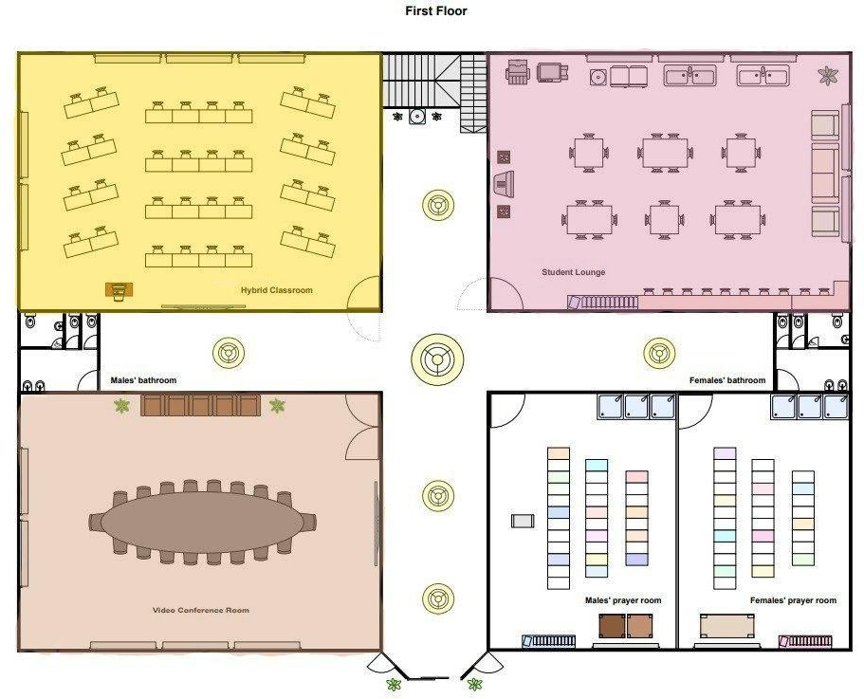
Figure 4.1.1

The ground floor work areas are designed to support teaching, collaboration, communication and student activities while ensuring reliable network connectivity. The hybrid classroom is equipped with desktop or lecturer PCs, interactive smart boards, projectors, wireless microphones and video conferencing cameras. These devices are connected using structured Cat 6 Ethernet cabling to access switches located in the network cabinet, ensuring stable wired connectivity for teaching equipment while wireless access points (APs) provide internet access for student’s laptops and mobile devices. The cabling is routed through ceiling trunking to maintain a clean layout and allow future expansion.

The video conference room functions as a collaboration and communication workspace that requires high network reliability. It is equipped with high-definition cameras, conference

microphones, display screen and a dedicated conferencing PC. All critical devices are connected via wired ethernet connections to minimize latency and packet loss during live meetings. A dedicated network switch port and quality-of-service(QoS) configuration ensure smooth audio and video transmission while proper cable management improves safety and maintenance.

A student lounge serves as an informal work and study area where students use personal laptops and mobile devices. This area mainly relies on wireless networking, supported by strategically placed access points to provide full coverage and sufficient bandwidth. Minimal wired cabling is required except for network uplinks to the access points and charging stations. This design allows flexibility, mobility and ease of use while maintaining secure network access.

    - First floor
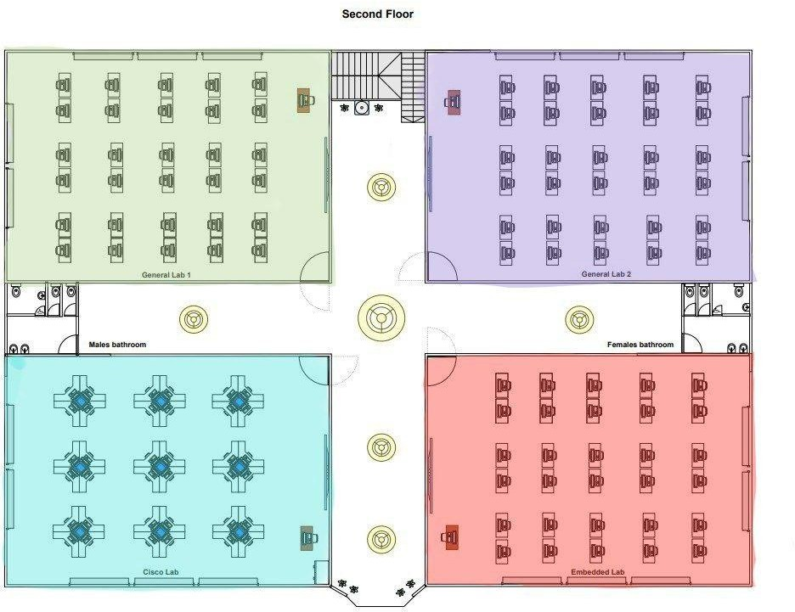

Figure 4.1.2

The first floor work areas are dedicated to technical and laboratory-based learning, requiring structured cabling and high-performance network devices. The Cisco lab is a specialized networking workspace equipped with multiple desktop computers, Cisco routers, switches, patch panels and racks. Each workstation is connected using cat 6 ethernet cables to access switches, allowing students to perform routing, switching and network configuration exercises. Patch panels are used to organize cabling and simplify troubleshooting while lab follows a star topology for efficient network management.

The embedded lab supports hardware-based and IoT-related development activities. It is equipped with computers, microcontrollers, development boards, sensors and testing instruments. Workstations are connected through wired ethernet connections for stable data transfer while wireless connectivity is provided for IoT device testing. Proper power outlets, network points and cable trunking are arranged to ensure safety and ease of maintenance during hardware experimentation.

The general labs are designed for programming, software development and general computing tasks. Each lab contains approximately 30 desktop computers connected to a local switch using structured ethernet cabling. The switch uplinks to the main network to provide high-speed internet access. Wireless access points are also installed to support additional devices such as laptops. This combination of wired and wireless connectivity ensures reliability, flexibility and scalability for various academic activities.

  - The Distribution and Connection of Devices

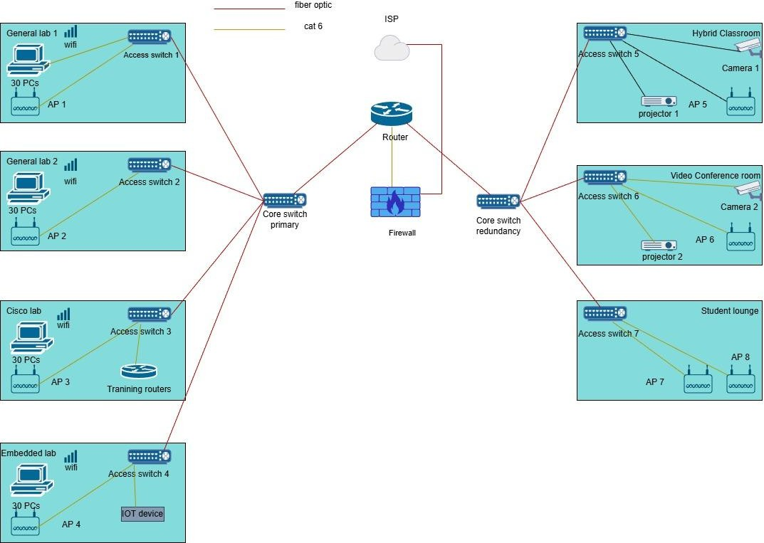
Figure 4.2.1

The network is designed to connect all rooms on both floors to the internet in a clear and organized way. Each room uses an access switch to connect end devices such as PCs, wireless access points, cameras, projectors, training routers, and IoT devices using Cat 6 cables.

All access switches are connected to the core switches using fiber optic cables to support higher bandwidth communication between floors. Two core switches are used to improve network reliability. A firewall is included in the network design to provide security control for internal network traffic. It is used to protect internal resources, and the ISP provides internet and external network services for the building.

Ground floor
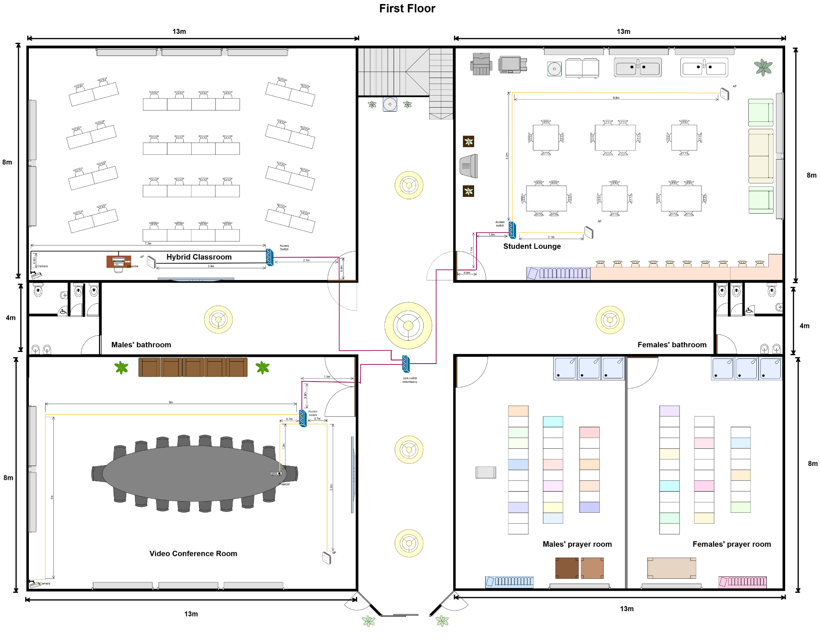

Figure 4.2.2

Backbone Cabling

The backbone cabling in this network design is used to interconnect the main network distribution points and to support high-speed data transmission across the building. Fibre optic cables are selected as the backbone medium due to their high bandwidth capacity, low signal attenuation, and suitability for handling heavy network traffic.

Horizontal Backbone Cabling

Horizontal backbone cabling refers to the fiber optic connections that run across the same floor to link the Main Distribution Facility (MDF) to major network distribution paths. In the floor plan, horizontal backbone cabling is represented by red lines running along the corridors and central areas. These fiber optic cables distribute network connectivity from the MDF to different sections of the floor, ensuring efficient data flow to all work areas.
The horizontal backbone supports high network traffic generated by laboratories, classrooms, and collaboration spaces. It also reduces congestion by acting as the main high-capacity pathway before connections are distributed through CAT6 horizontal cabling to end devices.

Vertical Backbone Cabling

Vertical backbone cabling refers to the fiber optic connections that link network distribution facilities between different floors. In this design, vertical backbone cabling connects the MDF on the ground floor to the distribution points on the upper floor. This connection allows network services to be shared across floors while maintaining high performance and reliability.
Fiber optic cabling is used for vertical backbone connections because it supports long-distance transmission and provides scalability for future network expansion.

    - First Floor
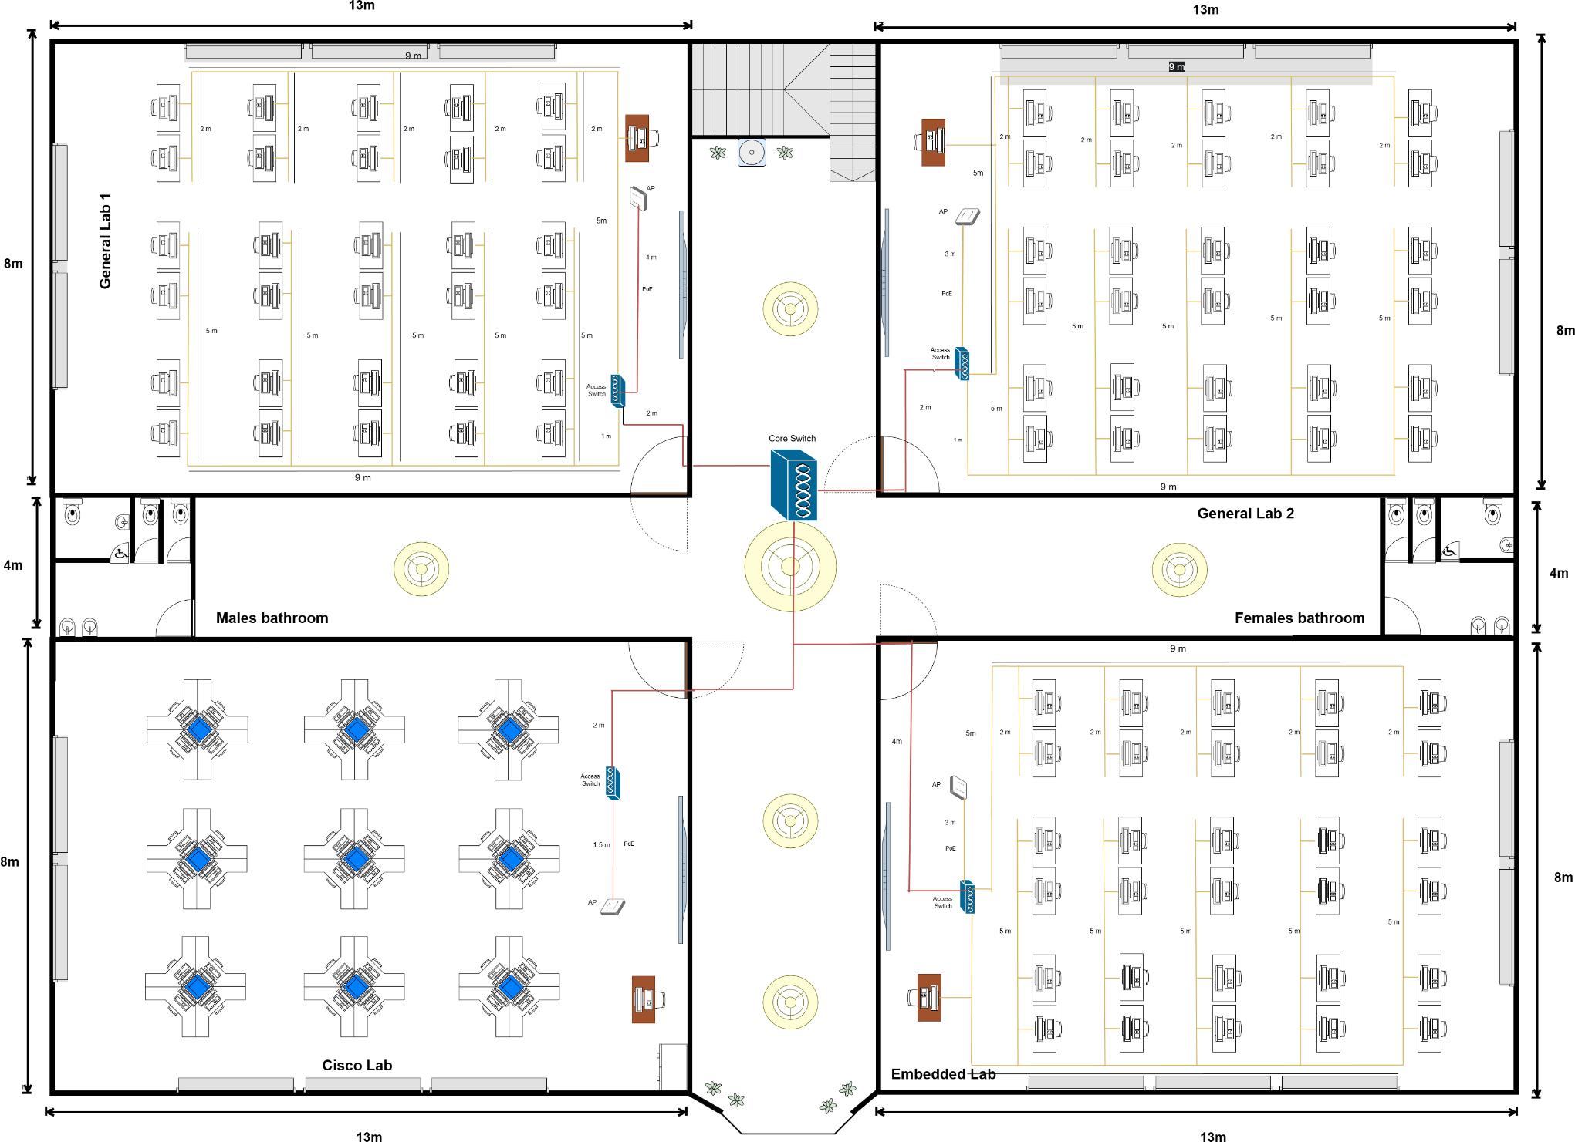

Figure 4.2.3

Main Cabling Network

The first-floor main cabling network is designed to connect all labs on the floor to the main network infrastructure. Fiber optic cables are used as the main network to ensure high-speed data transmission, low signal loss, and reliable performance for intensive lab use.
Horizontal Main Cabling Network

The first-floor horizontal main cabling network refers to the fibre optic connections that link the access switches in each lab (General Lab 1, General Lab 2, Cisco Lab, and Embedded Systems Lab) to the central switch.

These fibre optic connections run along the corridors and act as high-capacity paths, efficiently distributing network connectivity throughout the floor.
The horizontal main cabling network ensures a smooth flow of data from all labs before it is aggregated at the central switch and routed to the central network devices.

Horizontal Access Cables

Dual-stranded Cat6 cables are used to connect the horizontal access cables within each lab on the first floor. These cables connect desktop computers and wireless access points directly to the local access switch in each lab, providing a stable, high-speed network connection for peripheral devices

Vertical Backbone Cables

Vertical backbone cables connect the network infrastructure on the first floor to the existing ground floor network. Optical fiber is used for this connection to support long-distance transmission, high bandwidth, and future scalability between floors.

Number of Connections, Patch Cords, and Switch Ports Needed

Each wired device such as computers, smart boards, video conferencing equipment, routers, switches, and wireless access points is considered one network connection. For every network connection, two patch cords are required which is one connecting the device to the wall outlet and another connecting the patch panel to the switch. In addition, each connection occupies one switch port. The calculation is performed separately for each room and laboratory on the ground floor and first floor to ensure accurate network planning, efficient switch selection, and sufficient capacity for future expansion. The results of this analysis are then used to label the floor plan and support the overall network cabling design.

Ground Floor

Number of connection:

Area | Number of connection needed
Hybrid classroom | 3
Student lounge | 3
Video conference room | 3

Number of patch cords:

Area | Number of patch cords needed
Hybrid classroom | 6
Student lounge | 6
Video conference room | 6

Number of switch ports:

Area | Number of switch ports needed
Hybrid classroom | 3
Student lounge | 2
Video conference room | 3

Ground floor total:

Items | Number of quantity needed
Connections | 9
Patch cords | 16
Switch ports | 8

First Floor

Number of connection:

Area | Number of connection needed
General Lab 1 | 31
General Lab 2 | 31
Cisco Lab | 45
Embedded Lab | 30

Number of patch cords:

Area | Number of patch cords needed
General Lab 1 | 62
General Lab 2 | 62
Cisco Lab | 90
Embedded Lab | 60

Number of switch ports:

Area | Number of switch ports needed
General Lab 1 | 31
General Lab 2 | 31
Cisco Lab | 45
Embedded Lab | 30

First floor total:

Items | Number of quantities needed
Connections | 137
Patch cords | 274
Switch ports | 137

Overall building total:

Items | Number of quantities needed
Connections | 146
Patch cords | 290
Switch ports | 145

  - Identify Cable Types and Lengths

    - Ground Floor

      - Total Length of Cat6 Ethernet Cables needed on the Ground Floor: Hybrid Classroom : 7.2 + 0.6 + 0.2 + 3.4 = 11.4m
Student Lounge : 6.6 + 4.2 + 2.1 = 12.9m
Video Conference Room : 8 + 5 + 0.3 + 1.3 + 0.7 + 0.7 + 2.5 = 18.5m Total = 42.8m

      - Total Length of Fibre Optic Cables needed on the Ground Floor: Hybrid Classroom : 2.1 + 0.6 = 2.7m
Student Lounge : 1 + 1.1 + 0.6 = 2.7m Video Conference Room : 0.9 + 1.5 = 2.4m
To connect with the Switch core that is on the Ground floor = 10m Total = 17.8m

    - First Floor
      - Cat6 Ethernet Cables
general lab1 = (9*2) + (5*5) + (2*5) + (5) + (4) + 1 = 63m . general lab2 = (9*2) + (5*5) + (2*5) + (5) + (3) + 1 = 62m. embedded lab= (9*2) + (5*5) + (2*5) + (5) + (3) + 1 =62m. Cisco lab = 1.5 m
Total = 188.5 m

      - Fibre Optic Cables general lab1 = 2m. general lab2 = 2m. embedded lab = 4m. Cisco lab = 2m.
To connect with the Switch core that is on the First floor = 10m Total = 20m.

Reflection Task 4

Through this task, we gained an understanding of how network design is planned based on a building’s floor layout. This task required us to identify work areas and decide suitable device placement, cabling paths and network connections for both floors. By analysing different spaces, we learned how network requirements depend on usage and how this affects cabling types, switch placement and connection distribution. This task helped us realise that a well planned physical layout is important to ensure network efficiency, safety and future scalability.
This task also allowed us to reflect on the practical aspects of network implementation such as estimating the number of connections, patch cords, switch ports and cable lengths needed. We are more aware of how small design decisions can impact cost, maintenance and performance. Overall, Task 4 strengthened our understanding of physical network design and improved our ability to plan a realistic and organized network infrastructure.

TASK 5

Details of subnetting and IP assignation to each lab and room

  - Subnet Mask

The network address assigned by the lecturer is: Network Address: 172.19.0.0/20
Subnet Mask: 255.255.240.0

Host Capacity Calculation

Subnet | Area | IP Address/ Subnet Mask (Binary) | IP Address/ Subnet Mask (Decimal) | Usable Account (Host)
0 | Student Lounge (WiFi) | 10101100.00010011.0000  0000.00000000 /  11111111.11111111.111111  11.00000000 | 172.19.0.0/24 | 256
1 | Hybrid Classroom | 10101100.00010011.0000  0001.00000000 /  11111111.11111111.111111  11.10000000 | 172.19.1.0/25 | 126
2 | General Lab 1 | 10101100.00010011.0000  0001.10000000 /  11111111.11111111.111111  11.11000000 | 172.19.1.128/26 | 62
3 | General Lab 2 | 10101100.00010011.0000  001.11000000 /  11111111.11111111.111111  11.11000000 | 172.19.1.192/26 | 62

4 | Cisco Lab | 10101100.00010011.0000  00010.00000000 /  11111111.11111111.111111  11.11000000 | 172.19.2.0/26 | 62
5 | Embedded Lab | 10101100.00010011.0000  0010.01000000 /  11111111.11111111.111111  11.11000000 | 172.19.2.64/26 | 62
6 | Network Devices | 10101100.00010011.0000  0010.10000000 /  11111111.11111111.111111  11.11100000 | 172.19.2.128/27 | 30
7 | Video Conference Room | 10101100.00010011.0000  0010.10100000 /  11111111.11111111.111111  11.11110000 | 172.19.2.160/28 | 14

  - Range of IP address, Network and Broadcast address for the subnet

Area | Subnet | Network Address | Usable IP range | Broadcast address
Student Lounge(WiFi) | 172.19.0.0/24 | 172.19.0.0 | 172.19.0.1-172.19.0.254 | 172.19.0.255
Hybrid Classroom | 172.19.1.0/25 | 172.19.1.0 | 172.19.1.1-172.19.1.126 | 172.19.1.127
General Lab1 | 172.19.1.128/26 | 172.19.1.128 | 172.19.1.129-172.19.1.190 | 172.19.1.191
General Lab2 | 172.19.1.192/26 | 172.19.1.192 | 172.19.1.193-172.19.1.254 | 172.19.1.255
Cisco Lab | 172.19.2.0/26 | 172.19.2.0 | 172.19.2.1-172.19.2.62 | 172.19.2.63
Embedded Lab | 172.19.2.64/26 | 172.19.2.64 | 172.19.2.65-172.19.2.126 | 172.19.2.127
Network Devices | 172.19.2.128/27 | 172.19.2.128 | 172.19.2.128-172.19.2.158 | 172.19.2.159
Video Conference Room | 172.19.2.160/28 | 172.19.2.160 | 172.19.2.161-172.19.2.174 | 172.19.2.175

  - Range of IP address for user types based on the area

Student Lounge Subnet: 172.19.0.0/24
Device | IP Address
Wireless Access Points | 172.19.0.1 - 172.19.0.10
Student Devices | 172.19.0.11 – 172.19.0.254

Hybrid Classroom Subnet: 172.19.1.0/25
Device | IP Address
Lecturer PC | 172.19.1.1
Smart Board | 172.19.1.2
Projector | 172.19.1.3
Camera & Audio Devices | 172.19.1.4 - 172.19.1.10
Student Devices | 172.19.1.11 - 172.19.1.126

General Lab 1
Subnet: 172.19.1.128/26

Device | IP Address
Lecturer (PC) | 172.19.1.129
Student (PCs) | 172.19.1.130 – 172.19.1.160

General Lab 2
Subnet: 172.19.1.192/26

Devices | IP Address
Lecturer (PC) | 172.19.1.193
Student (PCs) | 172.19.1.194 – 172.19.1.223

Cisco Lab
Subnet: 172.19.2.0/26

Devices | IP Address
Lecturer (PC) | 172.19.2.1
Student (PCs) | 172.19.2.2 – 172.19.2.31
Routers & Switches | 172.19.2.32 - 172.19.2.55

Embedded Lab Subnet: 172.19.2.64/26
Devices | IP Address
Lecturer (PC) | 172.19.2.65
Student (PCs) | 172.19.2.66 – 172.19.2.95
IoT / Embedded Devices | 172.19.2.96 - 172.19.2.110

Video Conference Room Subnet: 172.19.2.160/28
Devices | IP Address
Conference PC | 172.19.2.161
Camera | 172.19.2.162
Projector | 172.19.2.163
Display Screen | 172.19.2.164

Network Devices Subnet: 172.19.2.128/27
Devices | IP Address
Core Switch | 172.19.2.129
Access Switches | 172.19.2.130 – 172.19.2.140
Wireless Access Points | 172.19.2.141 - 172.19.2.150
Router | 172.19.2.151 - 172.19.2.158

Reflection Task 5

Through Task 5, we gained an understanding of subnetting and IP address allocation in an academic network environment. This task required us to carefully analyze the given network address and divide it into appropriate subnets based on different areas such as laboratories, classrooms, and shared spaces. By completing this task, we reflected on the importance of accurate subnet mask selection, correct calculation of network and broadcast addresses, and efficient use of available IP addresses. The process helped us realize that proper planning is important to ensure that each area has sufficient IP addresses while avoiding unnecessary address wastage.
This task also allowed us to reflect on how theoretical networking concepts are applied in real-world scenarios. Assigning IP ranges based on user types and device functions helped us better understand how networks are structured to support different activities and requirements. We learned that even small calculation errors can affect the entire network design.

Conclusion
The project is fully completed within a few weeks of work and tasks. Throughout this project, we faced a lot of problems and doubts when it came to designing a network. Although it was quite tough for us, we still managed to overcome the problems and complete all the tasks including fixing some errors we made while checking before submitting. The project that we made achieved the goals that we set for each of the tasks, and from this project, we learned a lot of knowledge and gained experience in designing and building a network system that can be proposed in real life. In fact, we learned how to research and make decisions on the appropriate network devices based on the given Budget and requirements. This will be our first experience designing a LAN system, including the floor plan drawing and determining the best position for each device. Moreover, we also learned how to set up the IP address scheme for every network in a system. We believe that this experience will definitely come in handy for us to design a network system again in the future.

Besides the knowledge of implementing a network system, we also learned soft skills, which is a team working, which can only be gained when it comes to teamwork. We noticed the importance of teamwork when doing this project as we might have made some mistakes throughout this project and we will discuss and point out our doubts on certain points we do not understand. After this project, we believed that communication within the team was the main key to completing a group project.

In conclusion, we appreciate this opportunity to design a network system to gain experience and apply the knowledge learned from this course. We believe that the knowledge is beneficial in this project or even in the future, and without the bits of knowledge learned in this course, the project might not be done with the requirements mentioned.

Team Members and Responsibilities

Team Members | Responsibilities
Sarah Hamizah | Task 1: Design the ground floor and make changes on first floor  Task 2: Prepare questions and provide answer with proper citation and answer operational feasibility.  Task 3: Elaborate reasons why each device is chosen based on performance, reliability, future scalability and price. Supervises all modifications made by team members and finalises the report edits.  Task 4:Identify cable types and cable lengths along with identifying work areas on the ground floor and first floor according to the approved floor plan.  Task 5: Checking the outcome based on the topology and examining the IP address chosen.  Task 6:
Nurul Huda Nabilah
Luo Cimei
Amr Khaled

- References
  - Shakya, A., Prasad, P. W. C., Alsadoon, A., Zajko, G., & Elchouemi, A. (2016, November). Development of the wireless Cisco networking laboratory pod. ResearchGate.
https://www.researchgate.net/publication/315916155_Development_of_the_Wireless_Cis co_Networking_Laboratory_pod

  - Diffen. (n.d.). Cable vs DSL.
https://www.diffen.com/difference/Cable_vs_DSL

  - Choudhary, H. (2022, August 14). What is Cable Modem- How it Works, Advantages & Disadvantages.
Available: https://etipsguruji.com/cable-modem/

  - Mitchell, B. (2019). Types of Ethernet cables and what they do. Lifewire. https://www.lifewire.com/what-is-an-ethernet-cable-817548

  - luciaclemares. (2023, June 21). What is Ethernet and what kinds of cables exist? Telefónica.
https://www.telefonica.com/en/communication-room/blog/what-is-ethernet-kinds-cables- exist/

  - Martindale, J. (2019, July 30). Ethernet cables come in all shapes and sizes. Here’s what you need to know. Digital Trends.
https://www.digitaltrends.com/computing/different-types-of-ethernet-cables-explained/

  - Sawehli, A. F., Alrashdan, M., & Al-Maatouk, Q. (2020). APU high-speed internet access: A literature review. ResearchGate.
https://www.researchgate.net/publication/342623507_APU_HIGHSPEED_INTERNET_ ACCESS_A_LITERATURE_REVIEW

  - Rojas, J. (2014). Advantages of web filtering & firewall. Tek-Help. https://www.tek-help.com/advantages-of-web-filteringfirewall/

  - ManageEngine. (2019). Network monitoring software by ManageEngine OpManager. https://www.manageengine.com/network-monitoring/network-monitoring-tools.html

  - Lamberti, A. (2023, November 2). A guide to different types of network monitoring tools: Unveiling the superheroes. Obkio.
https://obkio.com/blog/types-of-network-monitoring-tools/

  - Writer, S. (2020, February 14). Video Conferencing Setup Requirements: Your Checklist for Hardware and Software. Lifesize.
https://www.lifesize.com/blog/video-conferencingrequirements/

  - Angelina Twain. (2016). ‘How to set up a LAN Network’. Retrieved November 22, 2020, https://medium.com/@lia640230/how-to-set-up-a-lan-networkf648c90bf75c

  - Kim Staples. (2017). ‘How to set up a Local Area Network (LAN)’. Retrieved November 22, 2020,
https://www.broadbandchoices.co.uk/how-to/how-toset-up-a-local-area-network

  - Scribbr. (n.d.). APA style.
https://www.scribbr.com/category/apa-style/

  - Cisco Systems. (2023). Campus LAN and Wireless LAN Design Guide. Cisco Systems, Inc.
https://www.cisco.com/c/en/us/td/docs/solutions/CVD/Campus/cisco-campus-lan-wlan-d esign-guide.html

  - A Guide to Internet Speed vs. Bandwidth. (n.d.). Lightyear. https://lightyear.ai/blogs/internet-speed-vs-bandwidth

  - Anant Gavali, Rambabu Vatti, Shraddha Gupte, September 2007, “Positioning of Wi-Fi Access Points for Optimum Coverage of Campus-Wide Network”
https://www.researchgate.net/publication/344570357_Positioning_of_Wi-Fi_Access_Poi nts_for_Optimum_Coverage_of_Campus_Wide_Network

  - “What is Data Redundancy” - Definitions and Drawbacks | Talend. Talend Real-Time Open Source Data Integration Software.
https://www.talend.com/resources/what-is-data-redundancy/

  - Great Learning, “Explain the cybersecurity measures,” Medium, May 18 2022. https://medium.com/@mygreatlearning/explain-the-cyber-security-measures

  - GeeksforGeeks, “Difference Between Router and Switch,” GeeksforGeeks, Jul. 11, 2025. https://www.geeksforgeeks.org/computer-networks/difference-between-router-and-switch/

  - HP Education products designer for K12 teaching & learning. (n.d.). HP. https://www.hp.com/us-en/solutions/education/products.html

  - What equipment is needed for the computer lab? (n.d.).
https://www.schoolnetindia.com/blog/what-equipment-is-needed-for-the-computer-lab/

  - Molenaar, R. (2025, November 20). Recommended Lab equipment for Cisco CCNA. NetworkLessons.com.
https://networklessons.com/cisco/ccna-200-301/recommended-lab-equipment-for-cisco-c cna

  - Fortinet, “What Is a Firewall? — CyberGlossary,” Fortinett https://www.fortinet.com/resources/cyberglossary/firewall
  - ​

Appendices
- The financial budget (what is bought, how much money is used and left, etc)

Details | Quantity | Amount (RM)
Income
Sponsor from Universiti Teknologi Malaysia |  | 1,600 000.00
Expenses
Router (Cisco ISR 4321) | 9 | 42876.99
Core Switches(Cisco Catalyst 9300) | 2 | 30000
Access Switch (Cisco Catalyst 9200) | 7 | 68740
Wireless Access Point(Cisco 1850 / 9115AX) | 13 | 28691
Firewall(Cisco Firepower 1010 NGFW) | 1 | 10000
Camera(HikvisionDS-2CD1043G2-LIU) | 6 | 1974
Projector(Optoma HD28e) | 6 | 17454
Screen(Manual pull-down screen) | 6 | 1300.56
Printer (HP LaserJet Pro M404dn) | 2 | 3000
IOT Devices(Raspberry Pi 4) | 30 | 9000
Desktop computer(HP ProDesk 400 G9) | 132 | 900240
Cable(

Total expenses
Balance (income - total expenses)

Rubric

Pictures
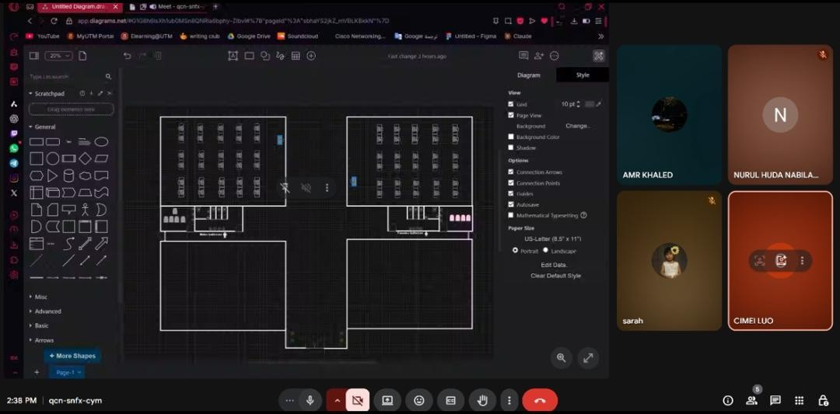
Task 1
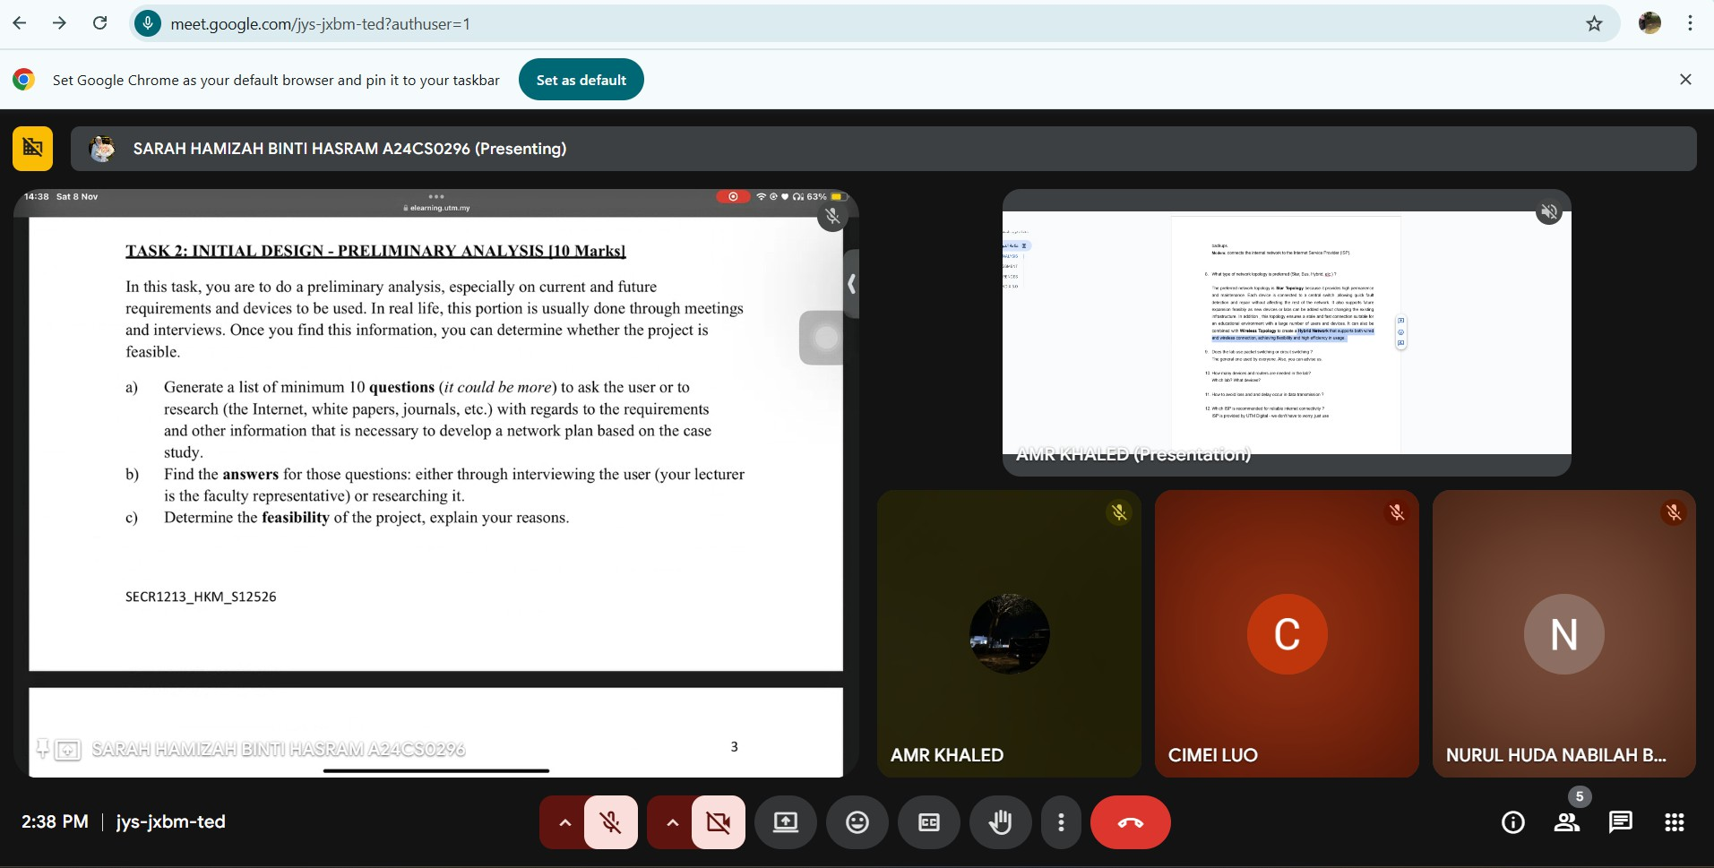
Task 2

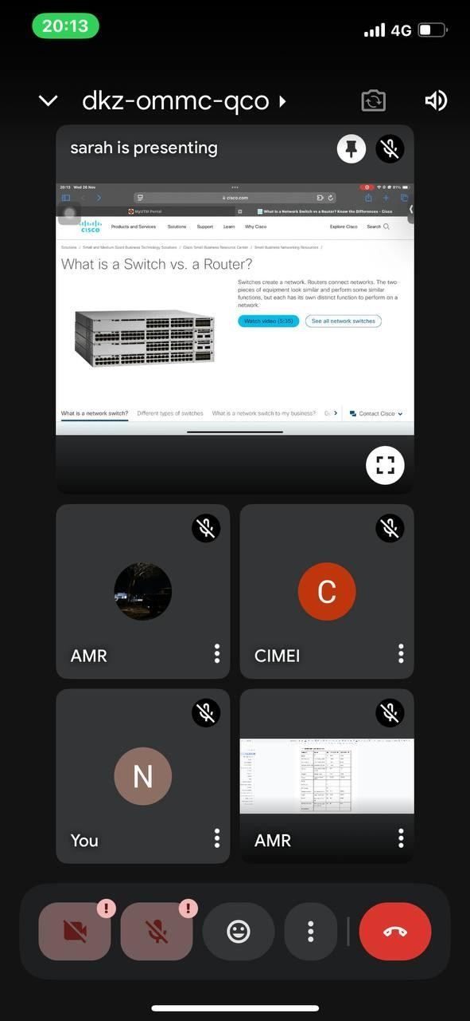

Task 3

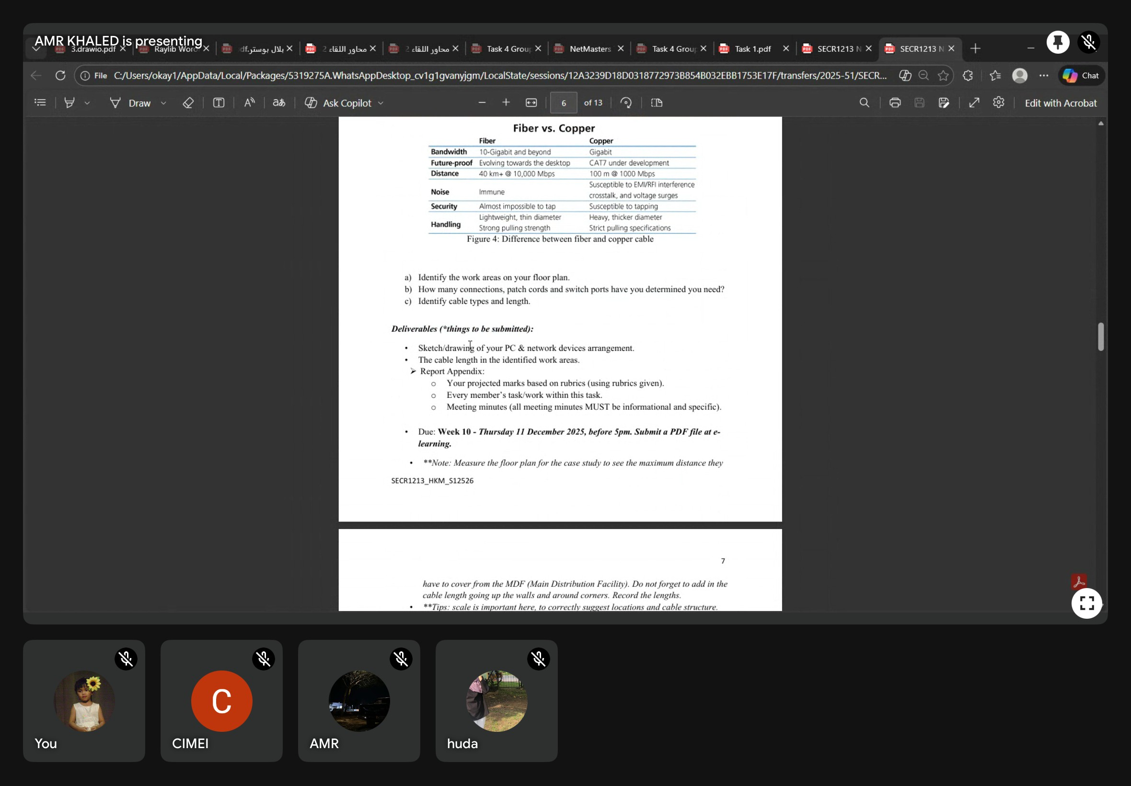
Task 4

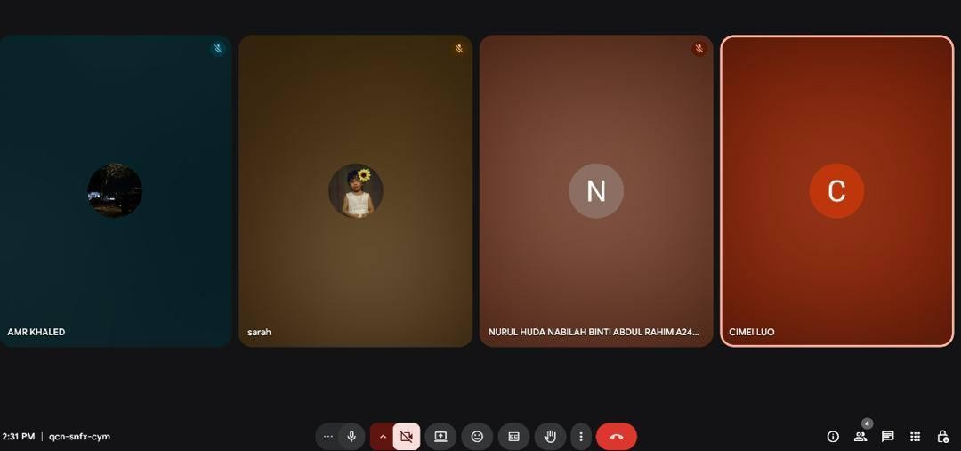
figureTask 5 meeting

People we met to discuss the project
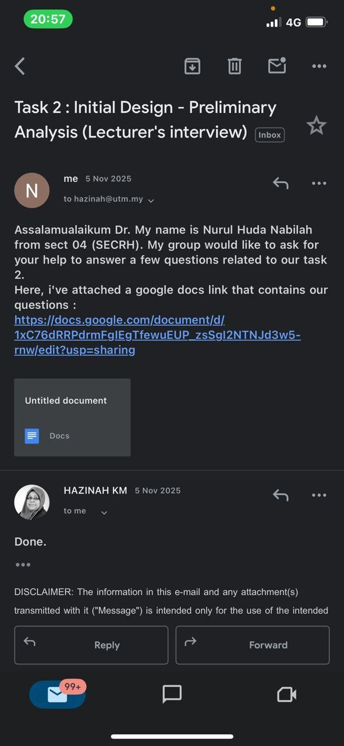


Meeting Minutes Task 1

Date / Time |  |  | 14 October 2025 / 1400
Location |  |  | Google Meet
Agenda |  |  | Distribution of workloads and brainstorming ideas
Meeting MC |  |  | Luo Cimei
Attendance
Name |  | Time |  | Reason for Absence
Sarah Hamizah |  | 1400 |  | -
Nurul Huda Nabilah |  | 1400 |  | -
Luo Cimei |  | 1400 |  | -
Amr |  | 1400 |  | -
Minutes
No. | Item Discussed |  | Ideas and the Person Giving It |  | Person in Charge & Date
1 | Find the website used for the sketch |  | Amr Khaled  - Suggested using the draw.io website to design and sketch the floor plan.  - General lab on the second floor. |  | Amr (14/10)
2 | First floor design |  | Sarah Hamizah  - Design the student lounge, video  conference room, prayer room, and hybrid classroom. |  | Sarah (14/10)
3 | Second floor design |  | Luo Cimei  - Design the embedded lab and Cisco lab. |  | Cimei (14/10)

4 | Final edits of the report | Huda Nabilah  - Supervises all modifications made by team members and finalises the report edits | Huda (14/10)
5 | Meeting ended | 1600

Meeting Minutes Task 2

Date / Time |  |  | 3 November 2025 / 1400
Location |  |  | Google Meet
Agenda |  |  | 1. Understand the details about task 2
 |  |  | 2. Suggest and select possible questions for task 2
Meeting MC |  |  | Nurul Huda Nabilah
Attendance
Name |  | Time |  | Reason for Absence
Sarah Hamizah |  | 1400 |  | -
Nurul Huda Nabilah |  | 1400 |  | -
Luo Cimei |  | 1400 |  | -
Amr |  | 1400 |  | -
Minutes
No. | Item Discussed |  | Ideas and the Person Giving It |  | Person in Charge & Date
1 | Determine the feasibility |  | Luo Cimei  - Proposed dividing feasibility into four main categories which is schedule, economic, operational and technical feasibility.  - Each aspect was assign to one member. |  | Cimei (3/11)
2 | Minimum number of question to ask |  | Amr Khaled  - Suggested preparing at least 12 questions  - Proposed that each member should be responsible for |  | Amr (3/11)

 |  | preparing a minimum of 3 questions.
3 | Decide who needs to interview | Huda Nabilah  - Will conduct an interview with lecturer (faculty representative) to clarify user requirement and technical needs  - Other member focus on online research | Huda (3/11)
4 | Report structure | Sarah Hamizah  - Reminded the team that each member should prepare their assigned questions and answer  - Responsible for compiling and editing the final report before submission. | Sarah (3/11)
5 | Meeting ended | 1600

Meeting Minutes Task 3

Date / Time |  |  | 24 November 2025 / 2000
Location |  |  | Google Meet
Agenda |  |  | 1. Choose a suitable LAN devices
 |  |  | 2. Talk about the budget given
Meeting MC |  |  | Sarah Hamizah Binti Hasram
Attendance
Name |  | Time |  | Reason for Absence
Sarah Hamizah |  | 2000 |  | -
Nurul Huda Nabilah |  | 2000 |  | -
Luo Cimei |  | 2000 |  | -
Amr |  | 2000 |  | -
Minutes
No. | Item Discussed |  | Ideas and the Person Giving It |  | Person in Charge & Date
1 | Identify devices needed for the network |  | Amr Khaled  - Suggested listing devices based on each lab and room  - Suggested and  comparing some devices to make sure a suitable device is selected |  | Amr (24/11)
2 | Research device brands and model |  | Luo Cimei  - Do a lot of research about the brand and model that are available in Malaysia  - Recommended checking Malaysian pricing in Senheng, VST ECS and Ingram Micro |  | Luo Cimei (24/11)

3 | Determine quantity of devices and check budget | Nurul Huda Nabilah  - Suggested calculating devices based on PC x Labs  - Recommended creating a spreadsheet to total the cost for all devices and compare the assigned budget. | Nurul Huda Nabilah (24/11)
4 | Final edits of the report and answer the reflection question | Sarah Hamizah  - Suggested writing justification based on performance, reliability, future scalability and price  - Supervises all modifications made by team members and finalises the report edits. | Sarah Hamizah (24/11)
5 | Meeting ended | 2200

Meeting Minutes Task 4

Date / Time |  |  | 18 December 2025 / 1400
Location |  |  | Google Meet
Agenda |  |  | Distribution of task 4
 |  |  | Analysis Task 4 requirement
Meeting MC |  |  | Amr Khaled
Attendance
Name |  | Time |  | Reason for Absence
Sarah Hamizah |  | 1400 |  | -
Nurul Huda Nabilah |  | 1400 |  | -
Luo Cimei |  | 1400 |  | -
Amr |  | 1400 |  | -
Minutes
No. | Item Discussed |  | Ideas and the Person Giving It |  | Person in Charge & Date
1 | Understanding Task 4 requirement |  | Amr Khaled  - Discussed the objectives of Task 4, focusing on identifying work areas, planning cabling layout, and drawing network distribution diagrams based on the floor plan from Task 1.  - Agreed that the explanation must clearly justify cabling types, switch placement, and connectivity design. |  | Amr (18/12)
2 | Identify work area arrangement |  | Sarah Hamizah  - Identified work areas on the ground floor and first floor according to the |  | Sarah (18/12)

 |  | approved floor plan.
3 | Design the network distribution diagram | Luo Cimei  - Proposed using a hierarchical star topology with a Main Distribution Facility (MDF) on the ground floor and an Intermediate Distribution Facility (IDF) on the first floor.  - Suggested drawing  separate network distribution diagrams for each floor for better clarity. | Cimei (18/12)
4 | Research suitable type of cabling | Huda Nabilah  - Suggested using CAT6 UTP cables for horizontal cabling within each floor due to high speed and cost efficiency.  - Proposed using fiber optic cable as backbone cabling between floors to support high bandwidth and future expansion. | Huda (18/12)
5 | Meeting ended

Meeting Minutes Task 5

Date / Time |  |  | 26 December 2025 / 1400
Location |  |  | Google Meet
Agenda |  |  | Distribution of task 5
 |  |  | Analysis Task 5 requirement
Meeting MC |  |  | Sarah Hamizah
Attendance
Name |  | Time |  | Reason for Absence
Sarah Hamizah |  | 1400 |  | -
Nurul Huda Nabilah |  | 1400 |  | -
Luo Cimei |  | 1400 |  | -
Amr |  | 1400 |  | -
Minutes
No. | Item Discussed |  | Ideas and the Person Giving It |  | Person in Charge & Date
1 | Determining Subnet Mask |  | Amr Khaled  - Choosing the different subnet masks  - Estimating the total number of IP addresses |  | Amr (26/12)
2 | Evaluating the  Network topology chosen |  | Sarah Hamizah  - Checking the outcome based on the topology  - Examining the IP address chosen |  | Sarah (26/12)
3 | Range of IP address, Network and Broadcast address for the subnet |  | Luo Cimei  - Determining which subnets to settle on |  | Cimei (26/12)
4 | Range of IP address for user types based |  | Huda Nabilah  - Determining IP |  | Huda (26/12)

 | on the area | addresses for devices in each room
5 | Meeting ended | 1530

